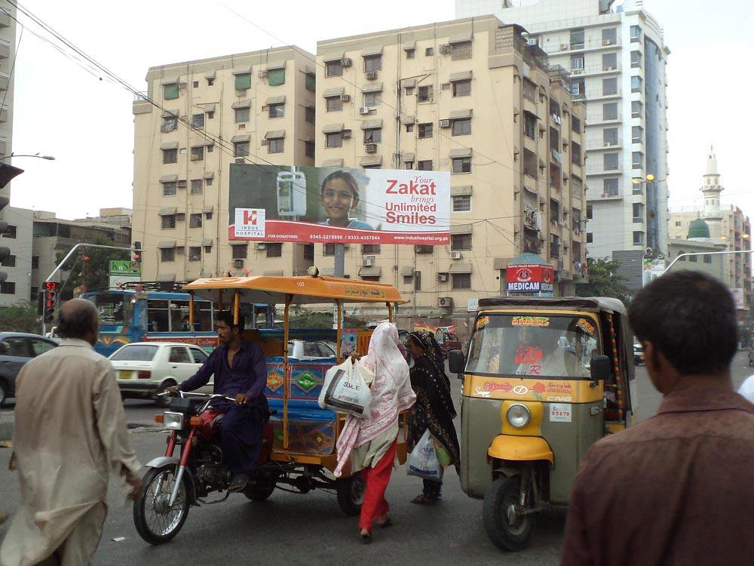

Location ID
3515
Size
15 x 45
Available Date

Current Display

Location Detail Main Sharfabad Signal towards 4 Minar Bahadurabad
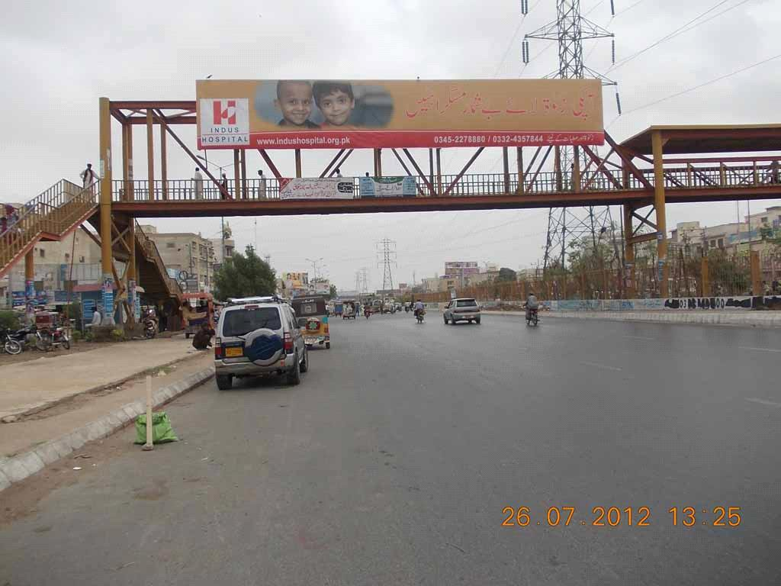

Location ID
3013
Size
60 x 10
Available Date

Current Display

Location Detail UP Morr North Karachi , Traffic Facing UP to Nagan (Double Sided)
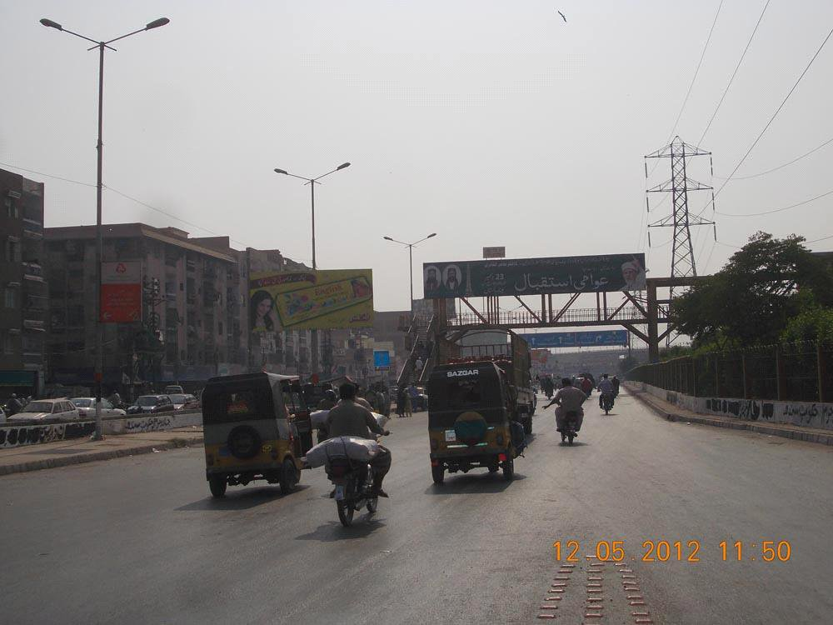

Location ID
3014
Size
60 x 10
Available Date

Current Display
Awami Istaqbal

Location Detail Nagan, North Karachi Traffic Facing UP to Nagan (Double Sided)
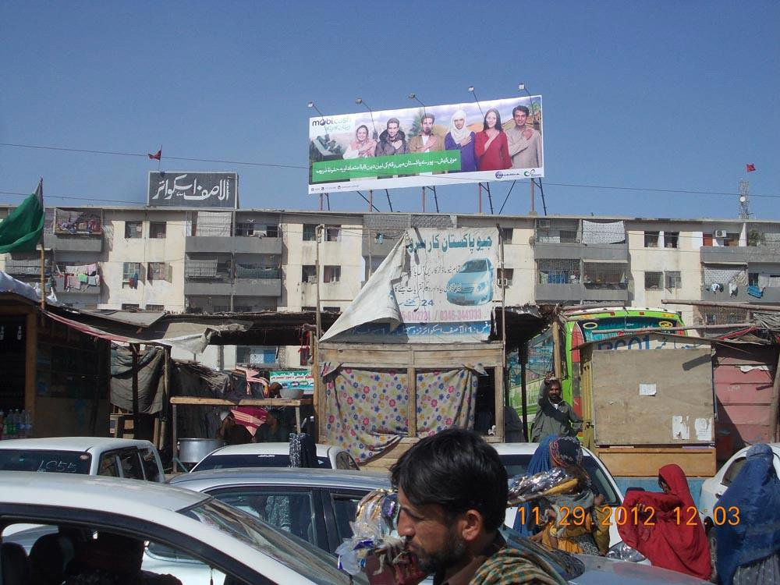

Location ID
177
Size
60 x 20
Available Date

Current Display

Location Detail Main Abul Hasan Isphani Road, Roof Top of Al-Asif Square
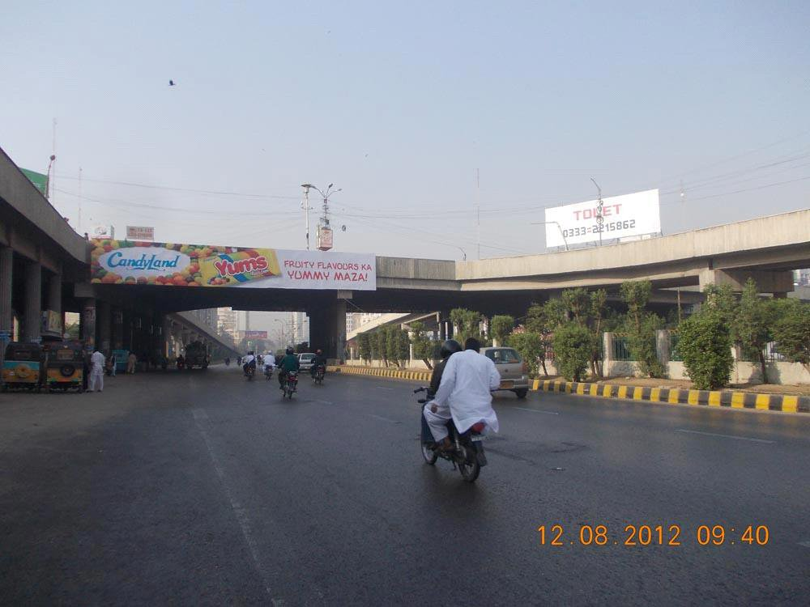

Location ID
887
Size
70 x 10
Available Date

Current Display
Yums

Location Detail Baloch Colony Flyover, Main Shahrah-e-Faisal (Double Sided)
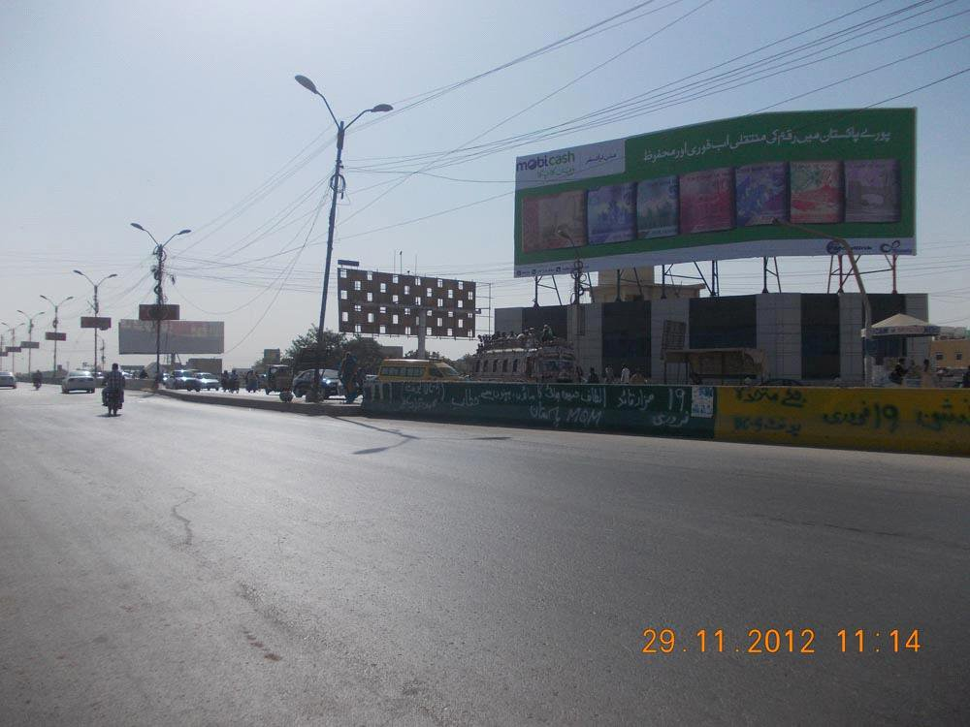

Location ID
170
Size
90 x 30
Available Date
15-Feb-13
Current Display
Mobilink

Location Detail Baloch Colony Flyover Traffic Coming From Awami Markaz
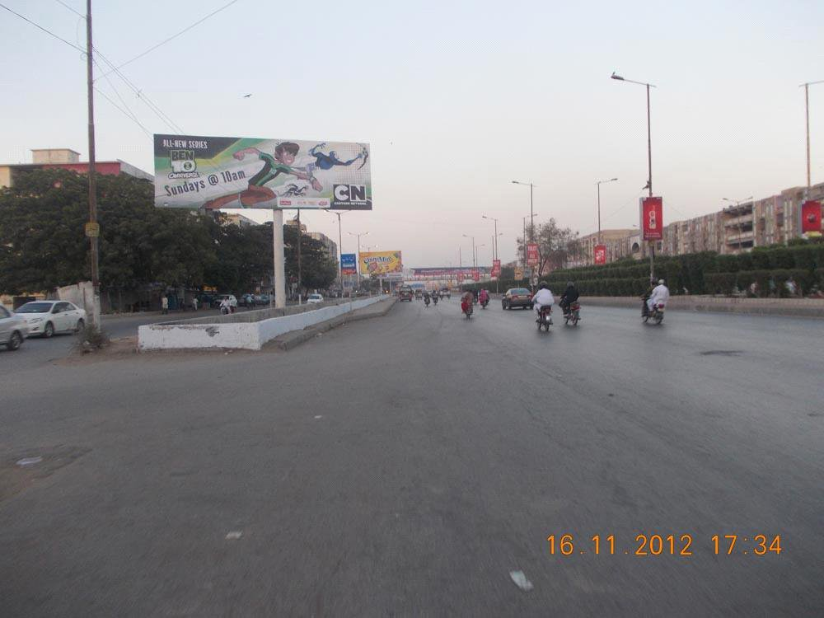

Location ID
874
Size
15 x 45
Available Date

Current Display

Location Detail Sakhi Hasan to Nagan Flyover, North Nazimabad
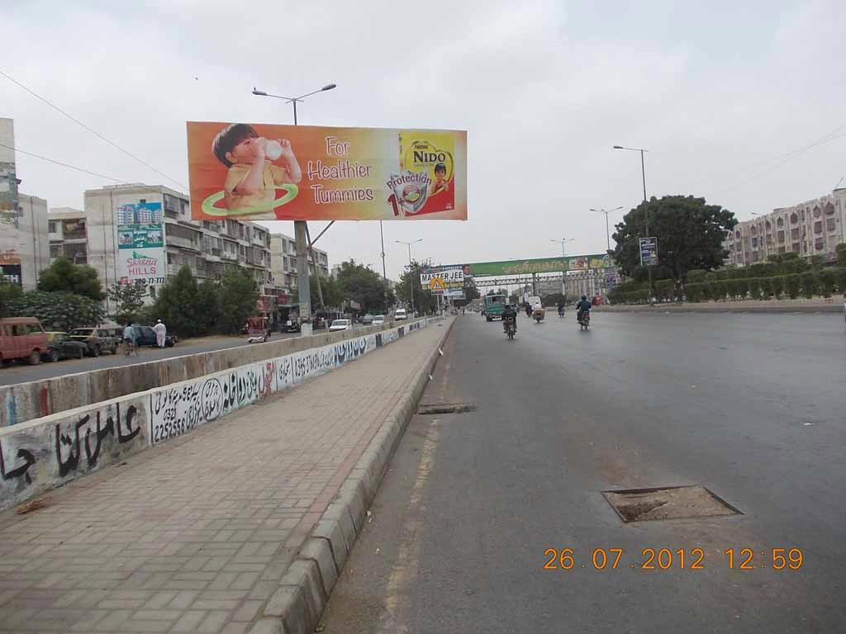

Location ID
3448
Size
15 x 45
Available Date

Current Display
Tolet

Location Detail Traffic facing Sakhi Hasan towards Nagan, North Nazimabad
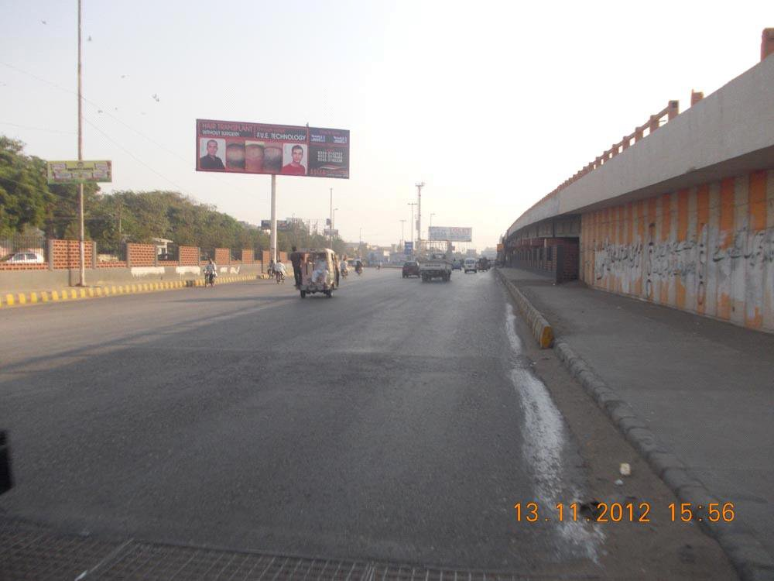

Location ID
1456
Size
15 x 45
Available Date

Current Display
Hair Transplant

Location Detail A.O Clinic towards Nazimabad Petrol Pump, Nazimabad
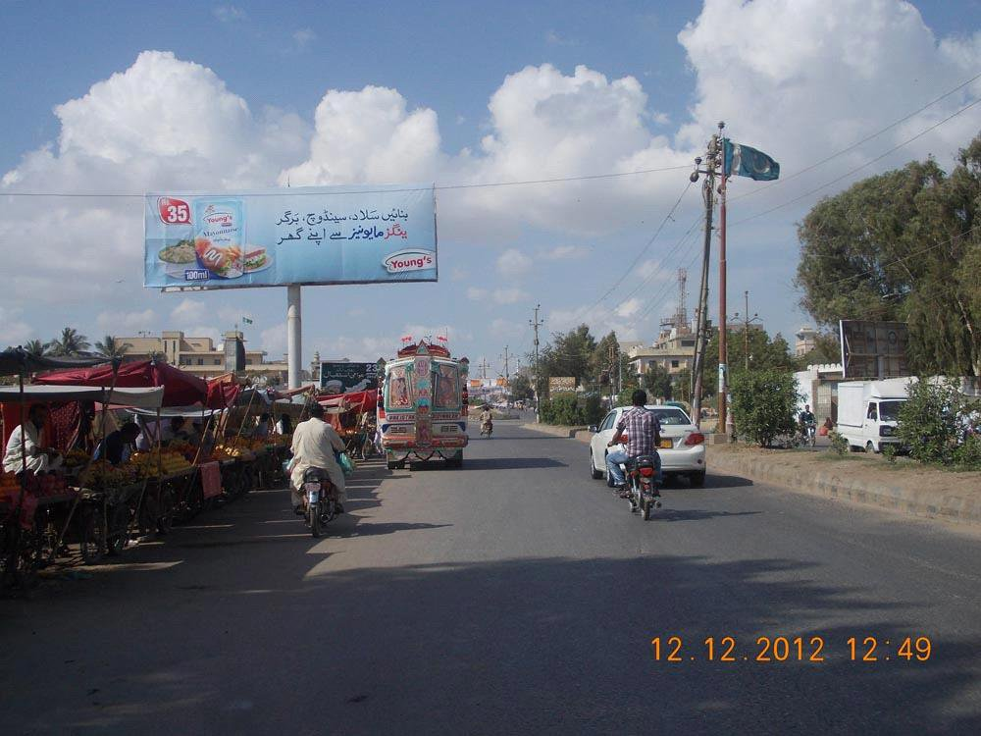

Location ID
4472
Size
15 x 45
Available Date
15-Jan-13
Current Display
Youngs

Location Detail Banaras Flyover to Orangi
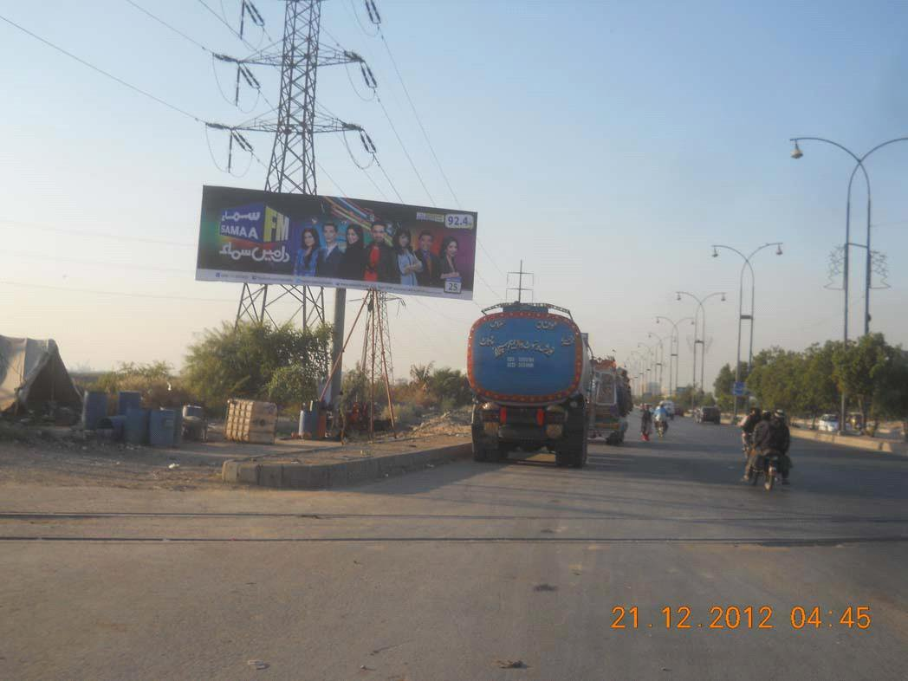

Location ID
3466
Size
45 x 15
Available Date
04-Jan-13
Current Display
Samaa FM

Location Detail Traffic facing Boat basin towards New American Embassy Mai Kulachi
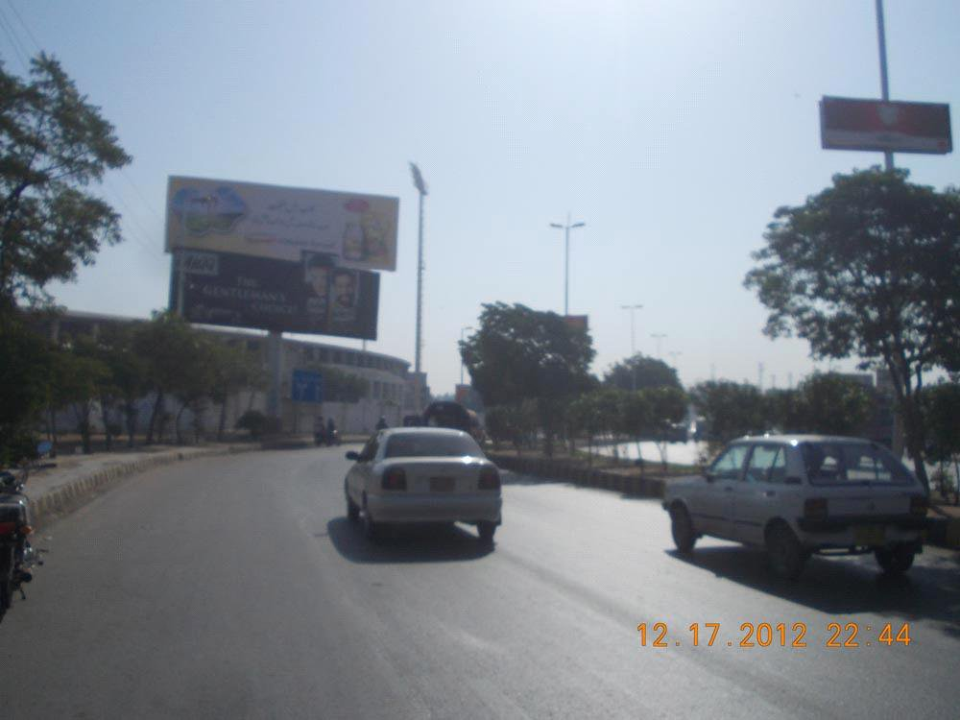

Location ID
3464
Size
60 x 20
Available Date
15-Jan-13
Current Display
Youngs

Location Detail Expo Centre towards Stadium (Above Site)
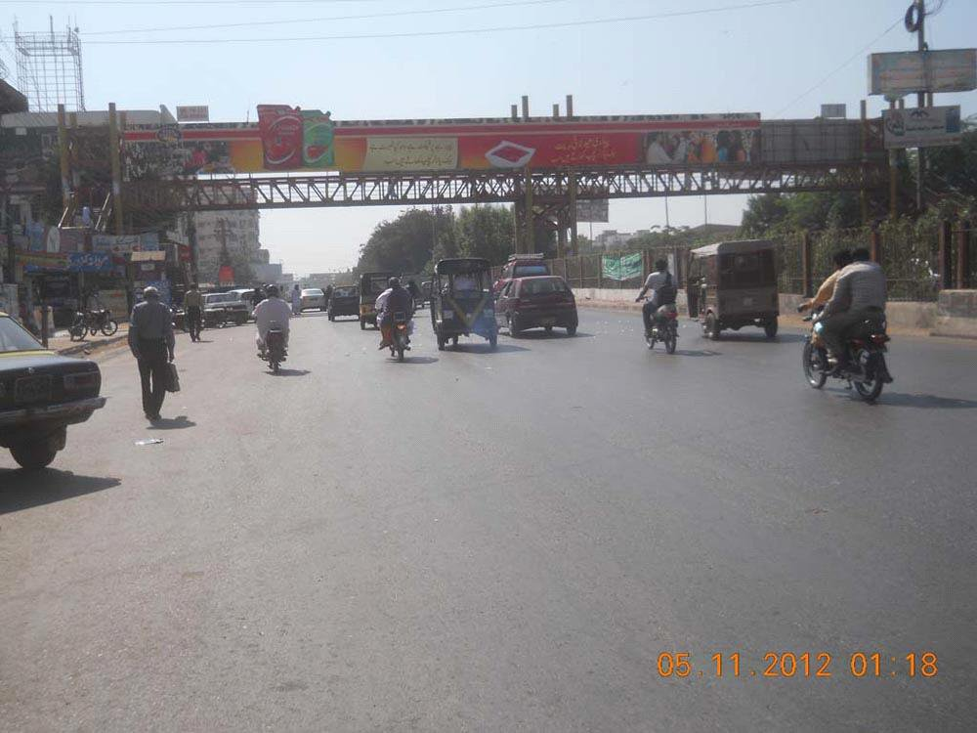

Location ID
888
Size
130 x 10
Available Date

Current Display
Awami Istaqbal

Location Detail University Road, Old Sabzi Mandi, near Askari Park, (Double Sided)
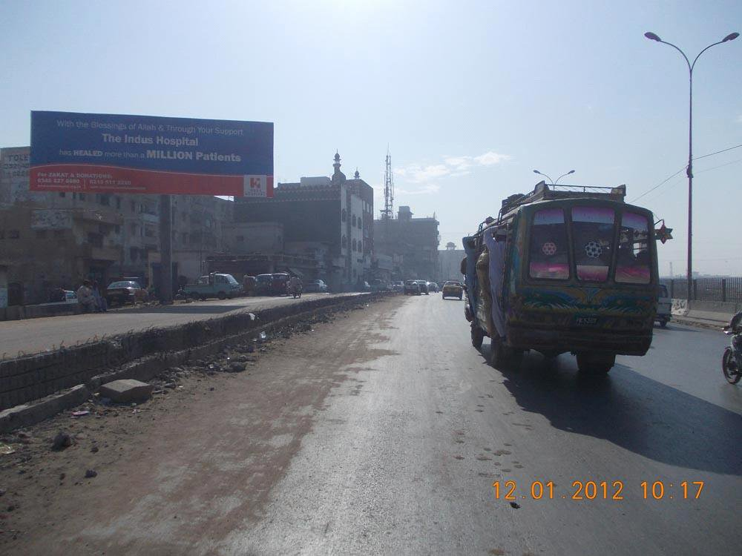

Location ID
4414
Size
15 x 45
Available Date
01-Mar-13
Current Display
Indus Hospital

Location Detail Main Maripur road towards ICI Flyover after Crown Cinema
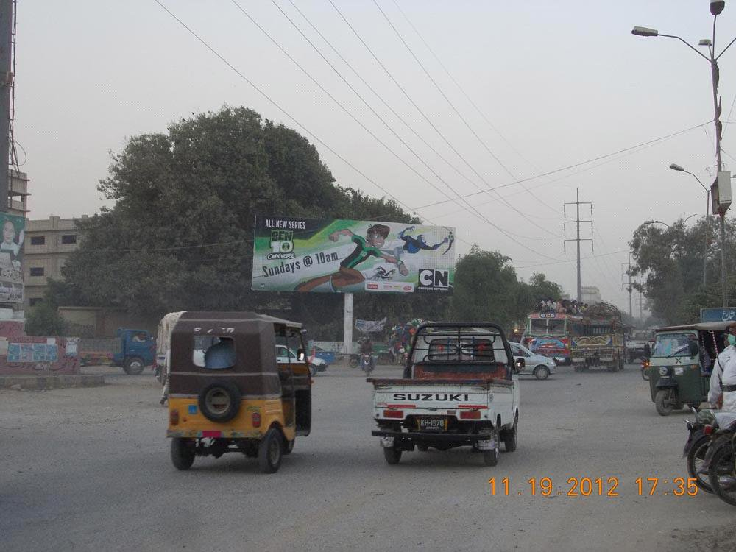

Location ID
4199
Size
15 x 45
Available Date

Current Display
Cartoon Network

Location Detail S.I.T.E Area Opp. Metro Cash & Carry Traffic Facing Habib Bank Chowrangi towards
Banaras
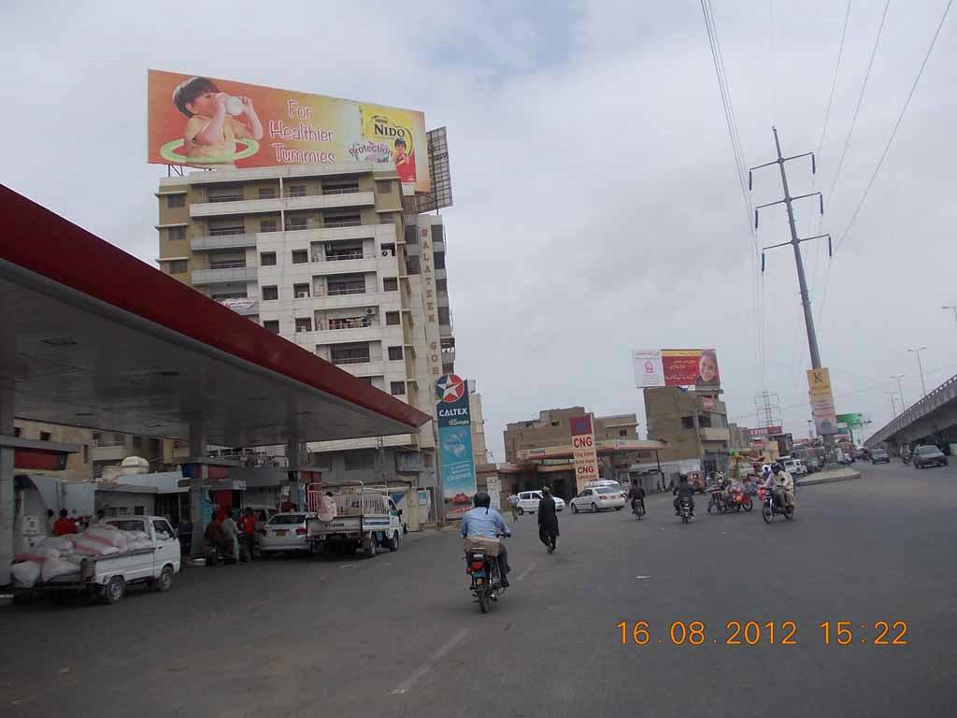

Location ID
169
Size
90 x 30
Available Date

Current Display

Location Detail Balouch Colony to KPT Flyover Express Way
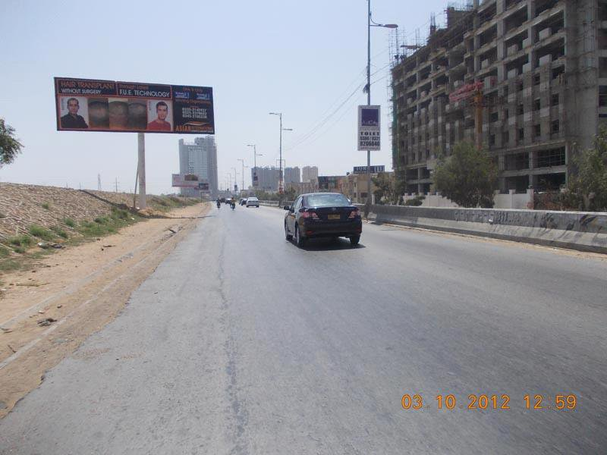

Location ID
3842
Size
15 x 45
Available Date

Current Display
Hair Transplant

Location Detail Express Way towards Khyban-e-Itehad
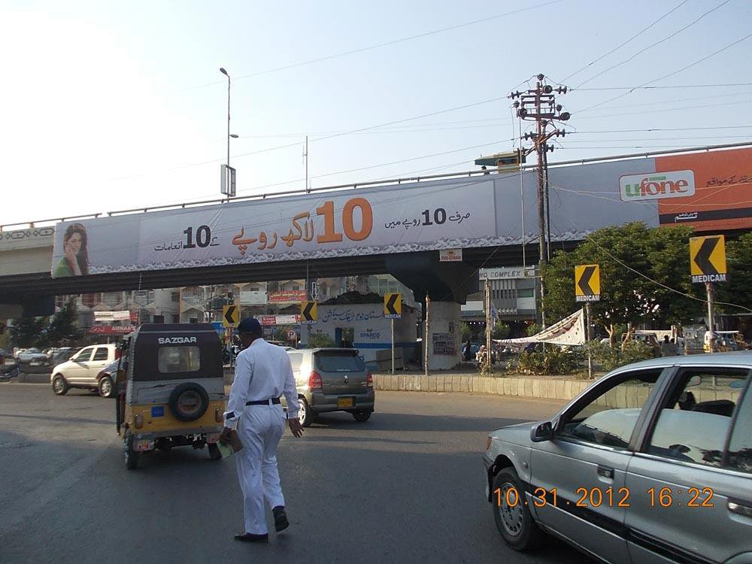

Location ID
893
Size
120 x 8.5
Available Date

Current Display

Location Detail Samama Flyover, Main University Road, traffic facing Gulistan-e-Jauhar towards
Samama Shopping Mall near Gulahmed Textile Store (Single Sided)
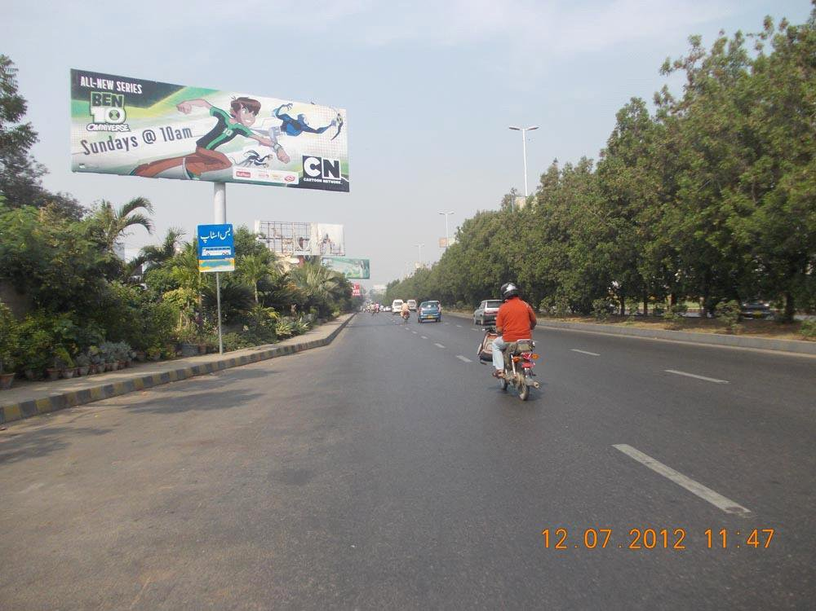

Location ID
3439
Size
15 x 45
Available Date
18-Dec-12
Current Display
Cartoon Network

Location Detail Main Karsaz road, Karsaz PNS towards Stadium (Option02)
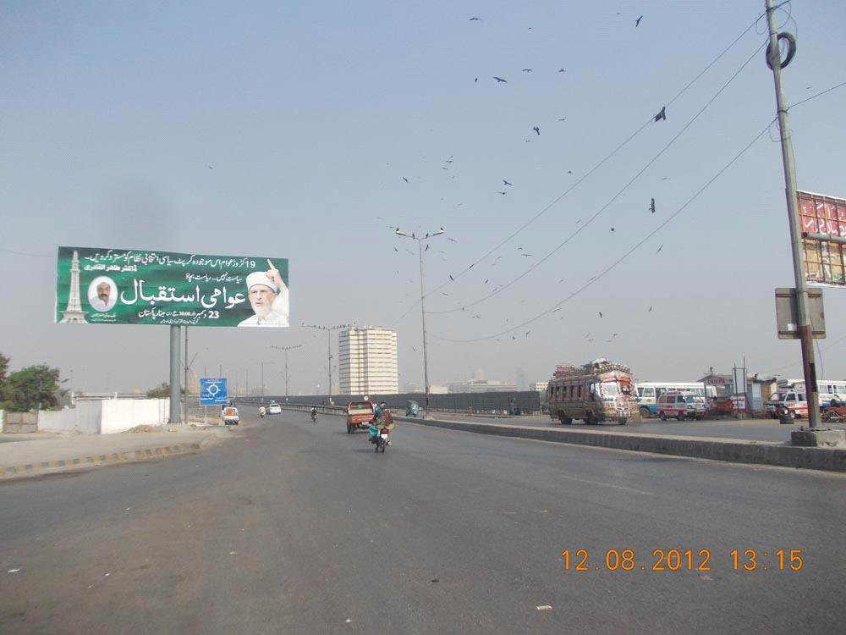

Location ID
4070
Size
15 x 45
Available Date

Current Display

Location Detail Kemari towards Netty Jetty Flyover
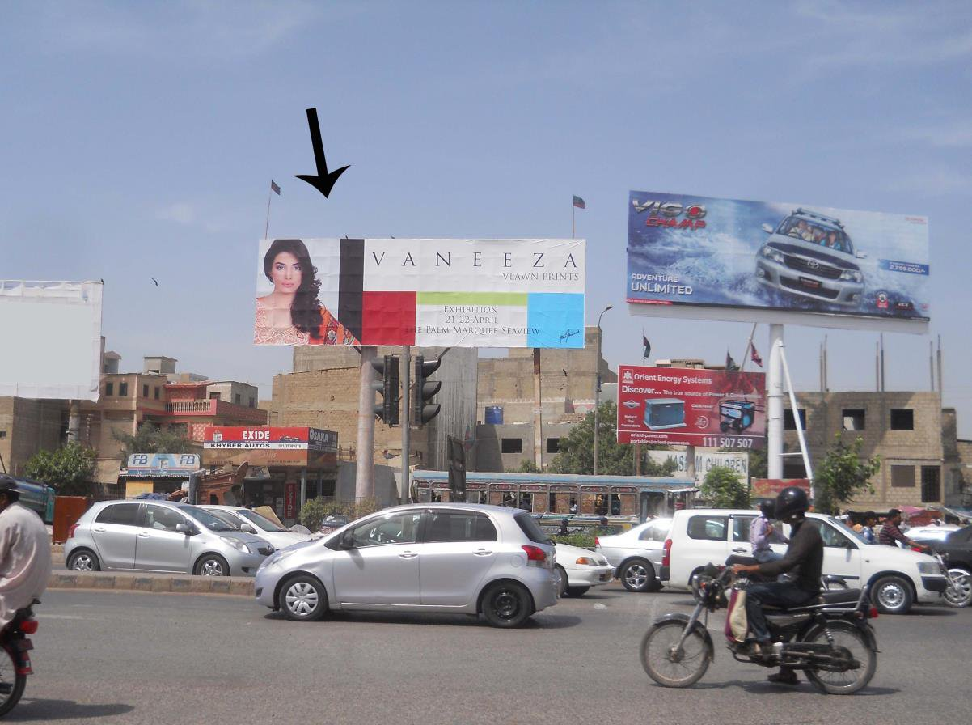

Location ID
2540
Size
60 x 20
Available Date
20-Dec-12
Current Display

Location Detail Seaveiw towards Khayaban-e-Ittehad Signal, Korangi road
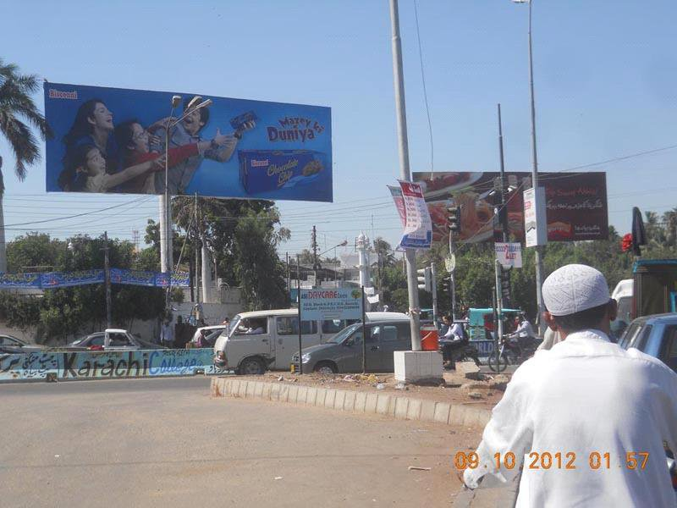

Location ID
2205
Size
60 x 20
Available Date

Current Display

Location Detail Tipu Sultan Road, Shaheed-e-Millat
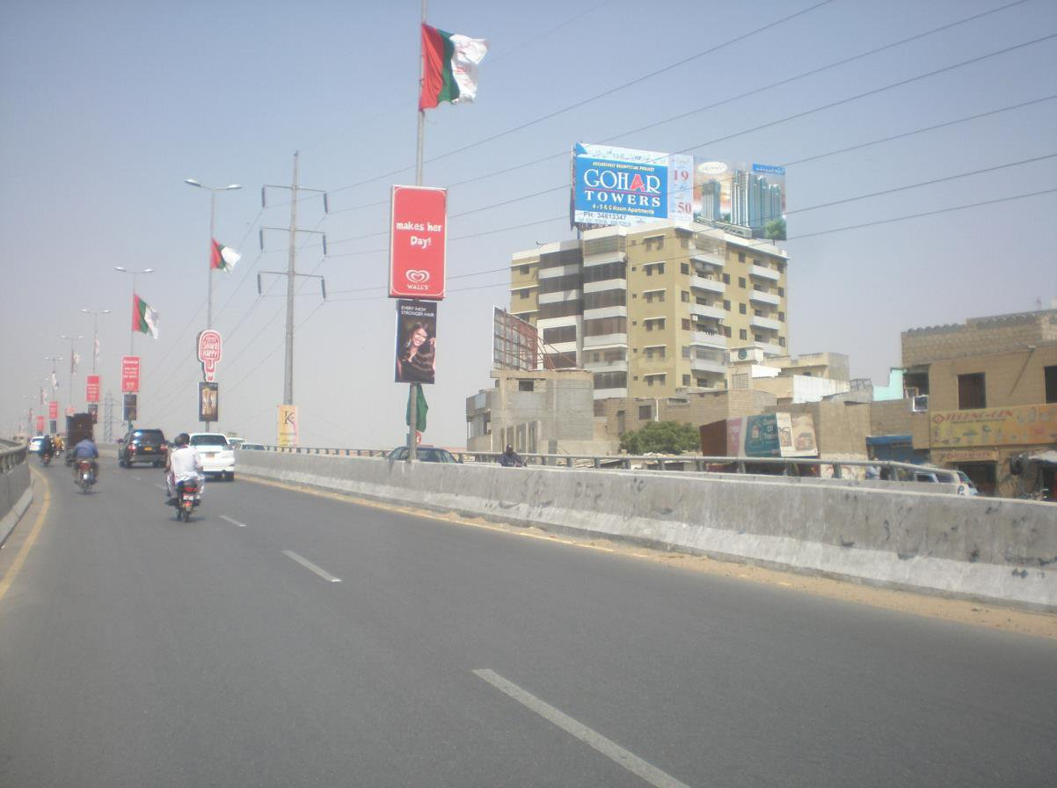

Location ID
1865
Size
90 x 30
Available Date

Current Display

Location Detail KPT Flyover to Balouch Colony Express Way
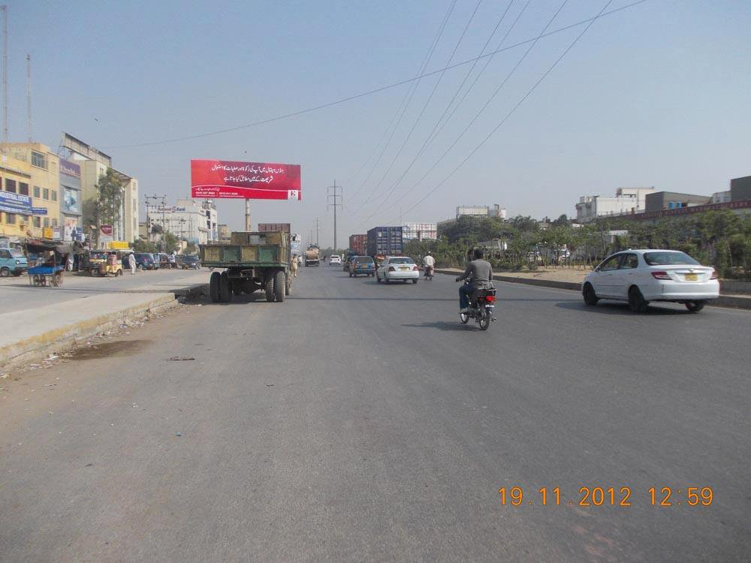

Location ID
3516
Size
15 x 45
Available Date
09-Jan-13
Current Display
Indus Hospital

Location Detail Brooks Chorangi towards Shan Chorangi, Korangi Industrial Area
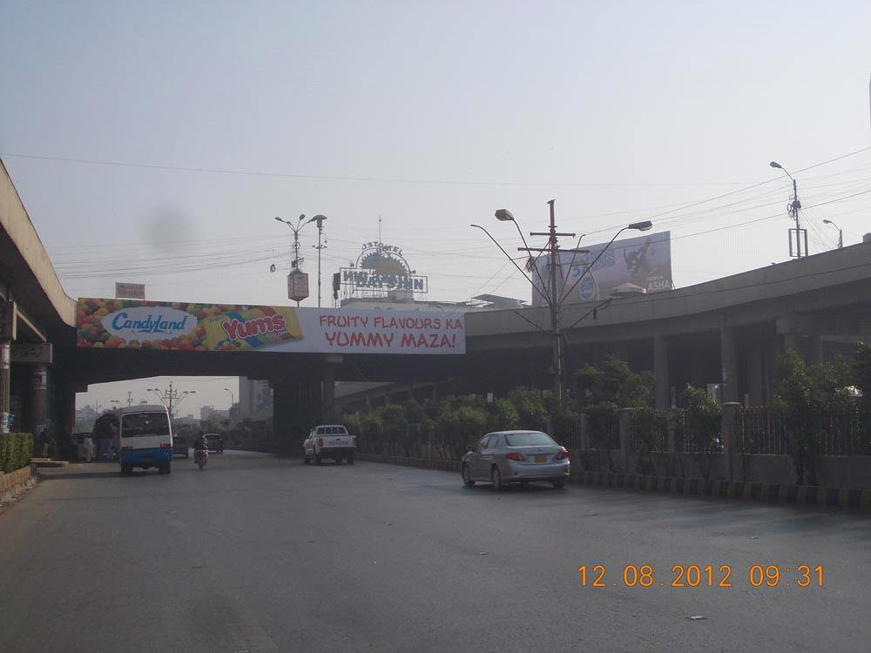

Location ID
1277
Size
90 x 10
Available Date

Current Display
Yums

Location Detail Baloch Colony Flyover, Main Shahrah-e-Faisal (Double Sided) Second Side ID No. 887
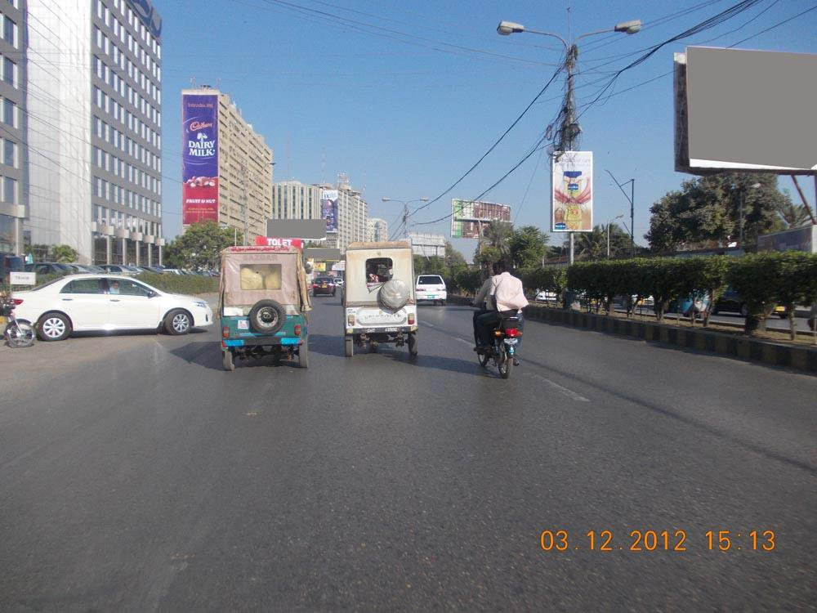

Location ID
171
Size
132 x 36.6
Available Date
10-Mar-13
Current Display
Cadbury Dairy Milk

Location Detail Main Shahrah-e-Faisal, Wall Panel at Sea Breeze Plaza
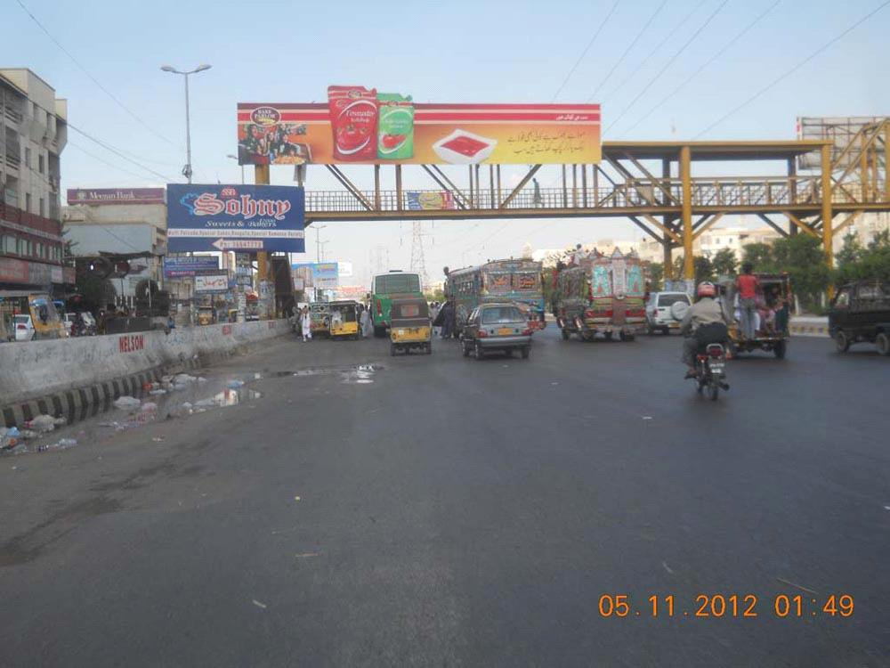

Location ID
2246
Size
60 x 10
Available Date

Current Display
Awami Istaqbal

Location Detail Nagan, North Karachi near Akhtar Pakwan (Double Sided) Option 01
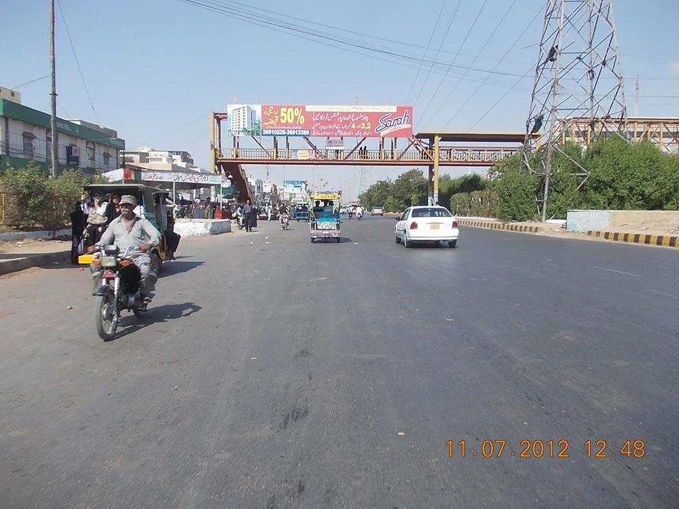

Location ID
1691
Size
60 x 10
Available Date
03-Jan-13
Current Display
Sarah Tower

Location Detail Up Morr North karachi, traffic facing Up Mor towards Nagan & Nagan towards Up Mor
(Double Sided)
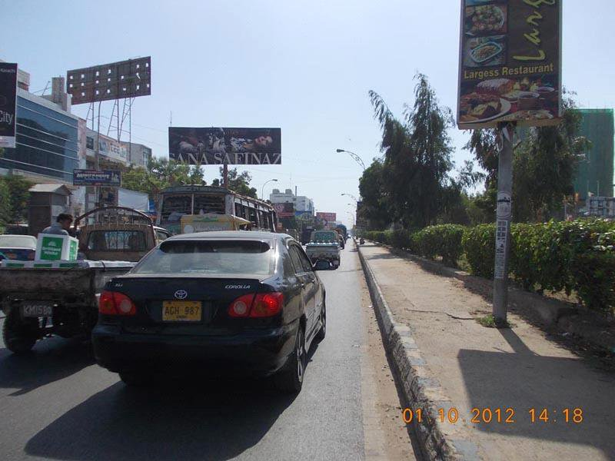

Location ID
2202
Size
15 x 45
Available Date

Current Display
Pathways British Scho

Location Detail Five Star to Hyderi Market North Nazimabad Before Saima Paari Mall
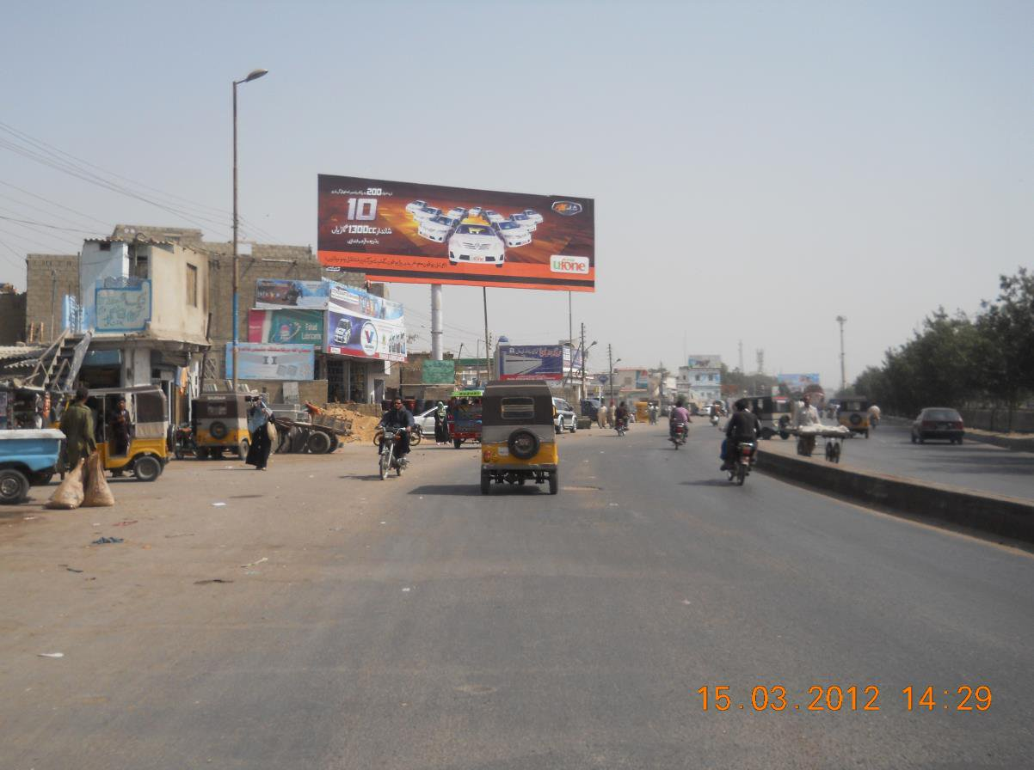

Location ID
3386
Size
60 x 20
Available Date

Current Display

Location Detail Nagan towards Shafiq Morr
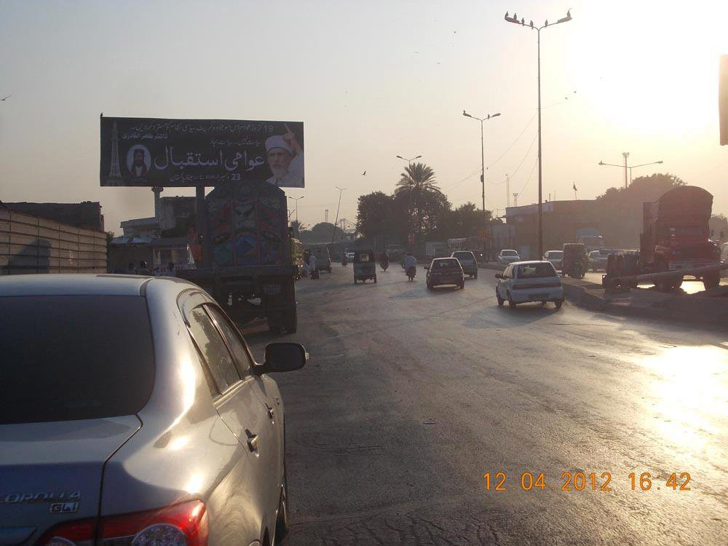

Location ID
4295
Size
15 x 45
Available Date

Current Display

Location Detail Netty Jetty Flyover towards Kemari
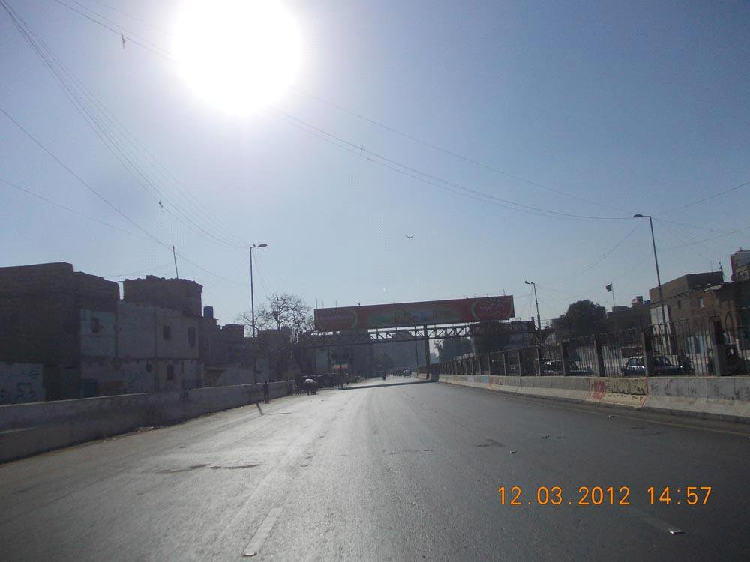

Location ID
4428
Size
90 x 10
Available Date
15-Jul-13
Current Display
Hashmi Gharana

Location Detail Before CDGK Parking Area, Traffic coming from New M.A. Jinnah Road going towards
Saddar (Double Sided)
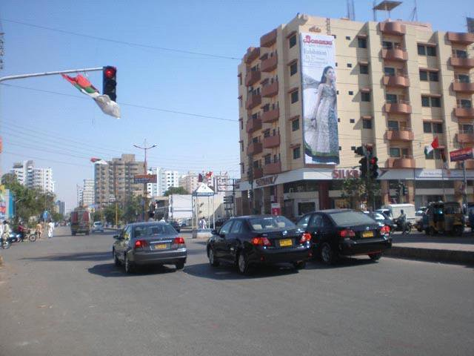

Location ID
187
Size
14 x 47
Available Date

Current Display

Location Detail Wall Panel at Khalid bin Waleed Road,
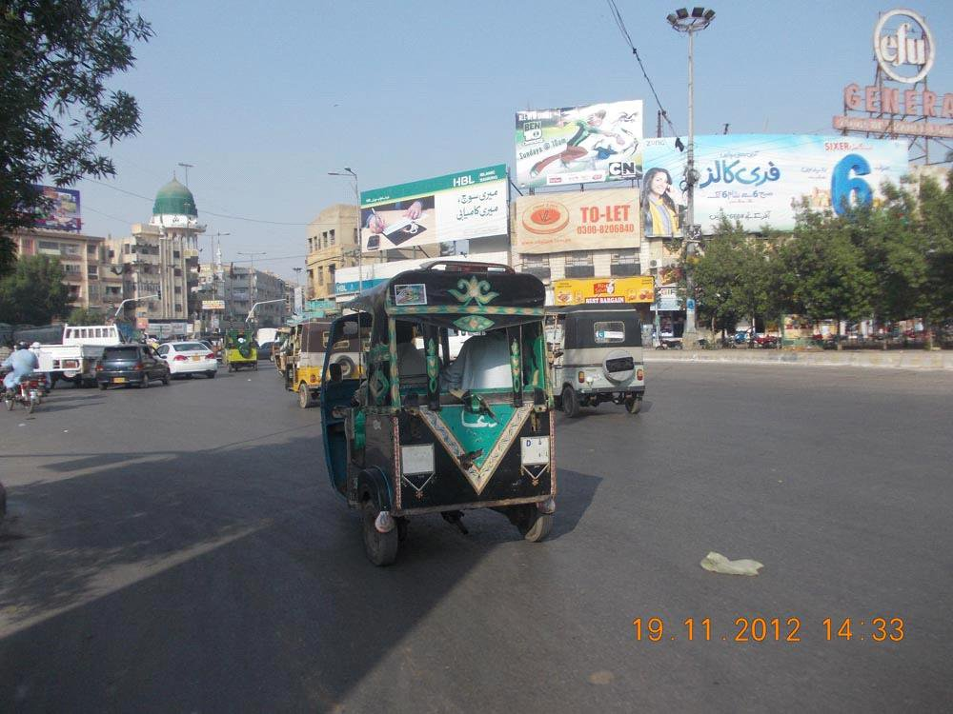

Location ID
181
Size
17 x 27
Available Date

Current Display
Cartoon Network

Location Detail Mian Guru Mandir Panel 01
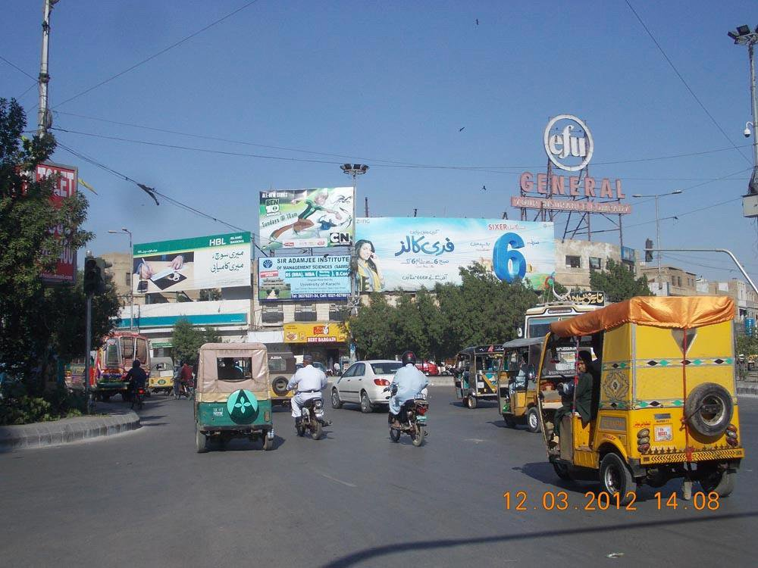

Location ID
188
Size
12 x 26
Available Date
01-Jan-13
Current Display
Sir Adamjee Institute

Location Detail Wall Panels at Guru Mandir Panel 02
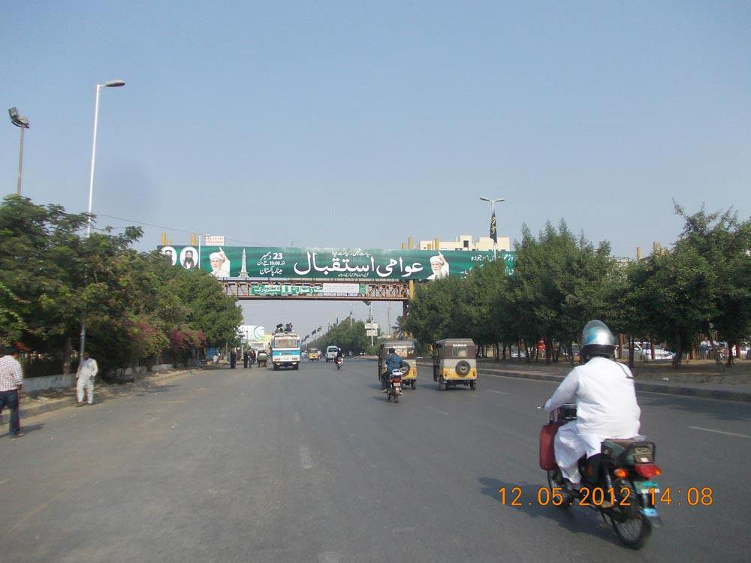

Location ID
1710
Size
130 x 10
Available Date

Current Display

Location Detail University Road, Old Sabzi Mandi, near Askari Park, Traffic coming from Jail Chowrangi
going towards Civic Center)
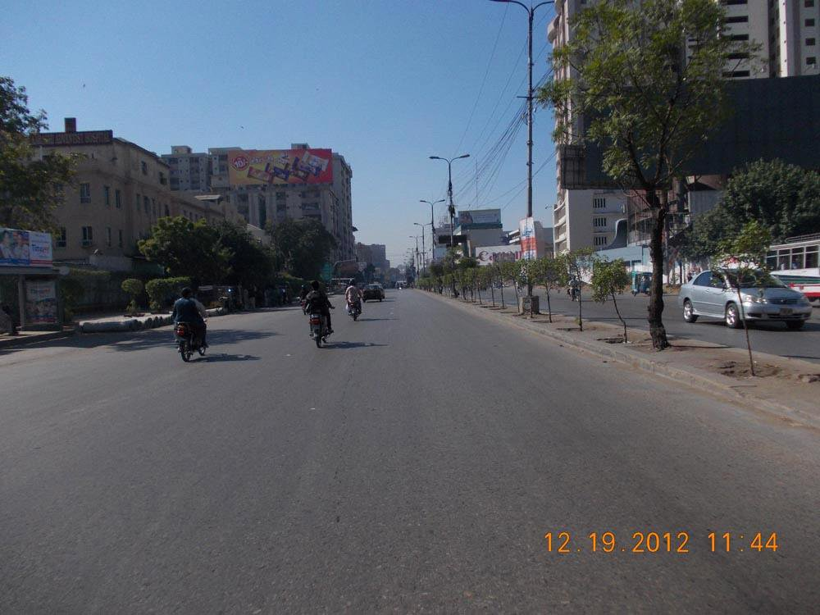

Location ID
172
Size
90 x 30
Available Date
01-Jan-13
Current Display
Peanut Peek

Location Detail Main M.A. Jinnah Road, Roof Top of Jinnah Plaza
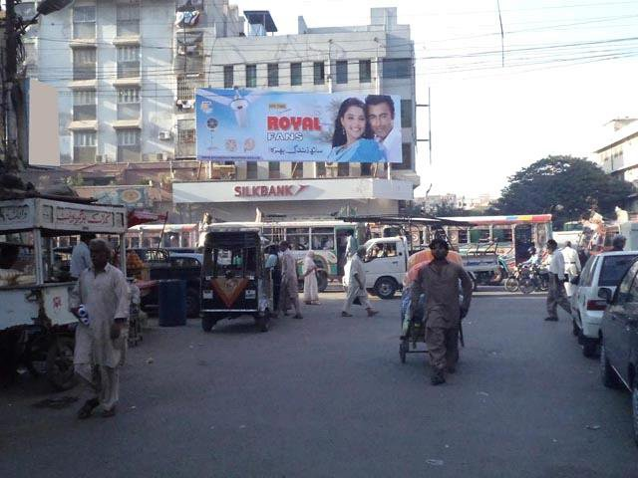

Location ID
178
Size
15 x 45
Available Date
12-Dec-13
Current Display
Royal Fan

Location Detail Main M.A Jinnah Road, Roof Top of Dinar Chamber
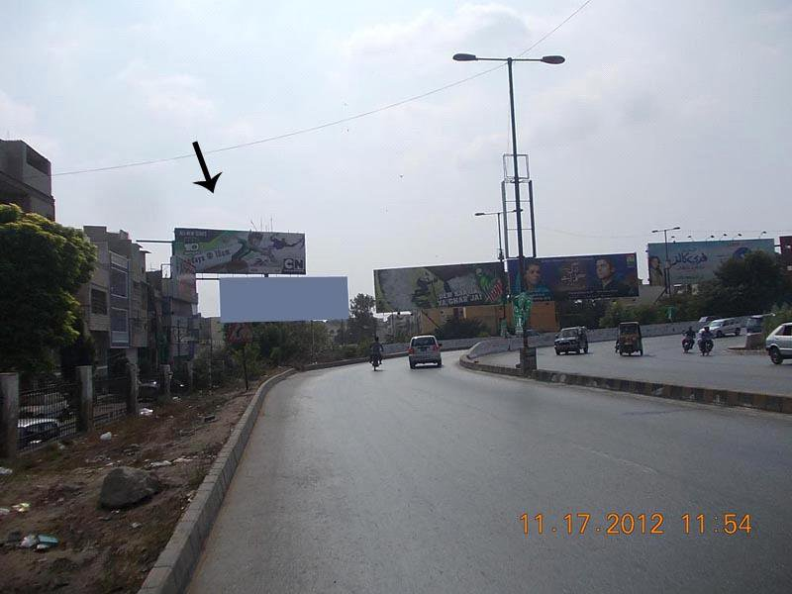

Location ID
174
Size
60 x 20
Available Date

Current Display

Location Detail Shahrah-e-Quaideen/Nursery Flyover Traffic Facing Tariq Road towards Shahrah-e-Faisal
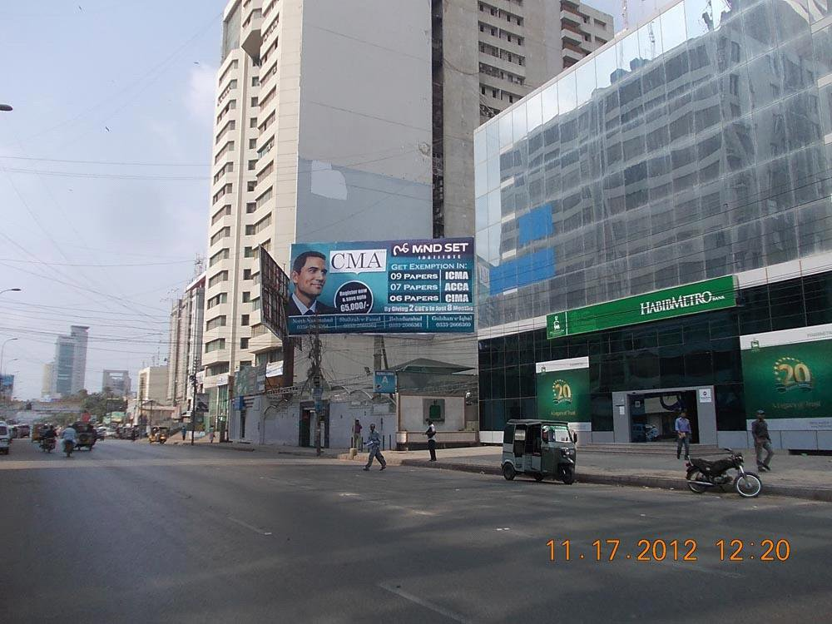

Location ID
176
Size
40 x 20
Available Date

Current Display

Location Detail I.I. Chundrigar Road Traffic Facing Shaheen Complex to Tower
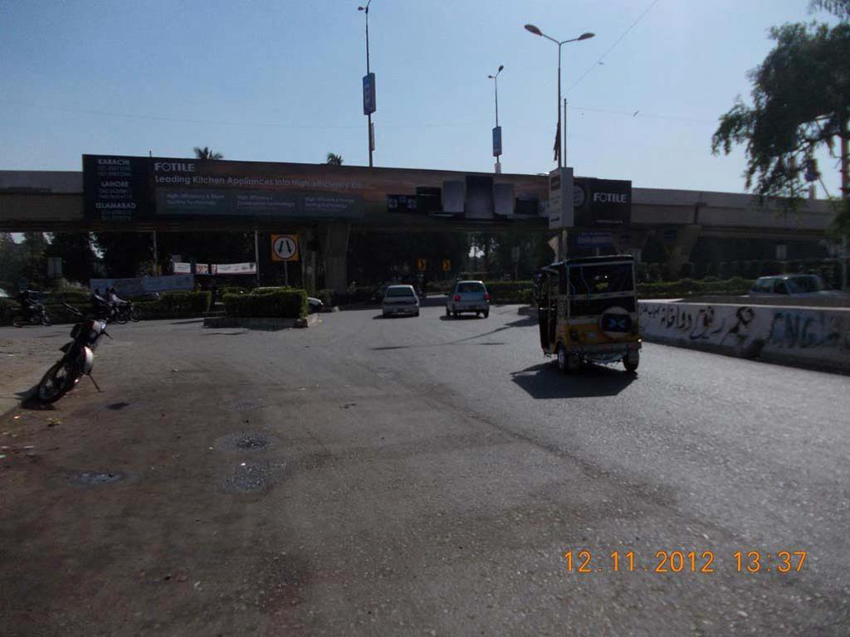

Location ID
4445
Size
125 x 12
Available Date
14-Feb-13
Current Display
Fotile

Location Detail Main Tipu Sultan Flyover Traffic Facing Tipu Sultan to Shahrah-e-Faisal
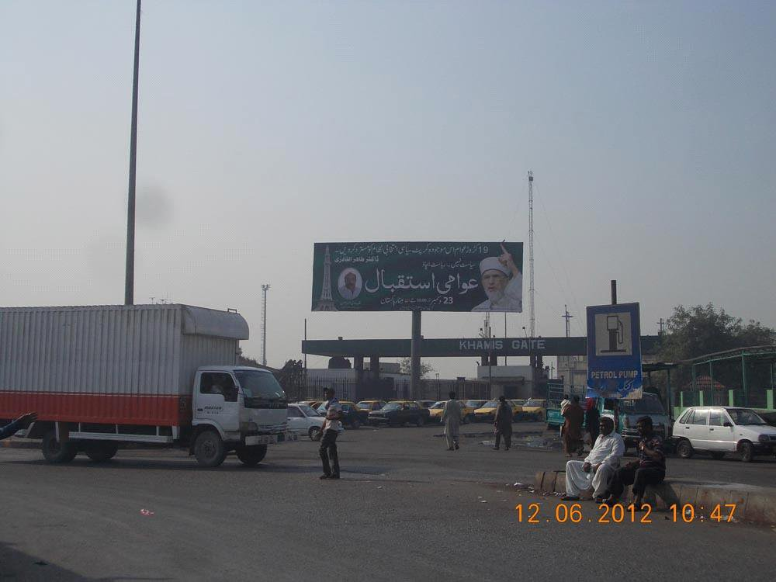

Location ID
3462
Size
15 x 45
Available Date

Current Display

Location Detail Adjacent to the Gate of Khami’s Facing from Mazar towards Keamari Opp. NLC Gate
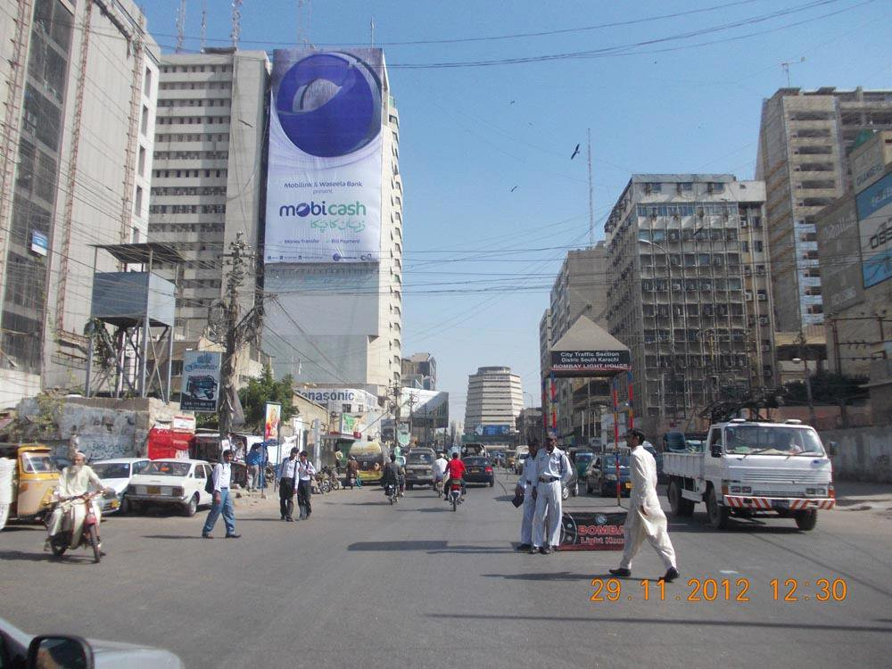

Location ID
182
Size
120 x 61
Available Date

Current Display
Mobilink

Location Detail Wall Panel at Saima Trade Tower, Main I.I. Chundrigar Road
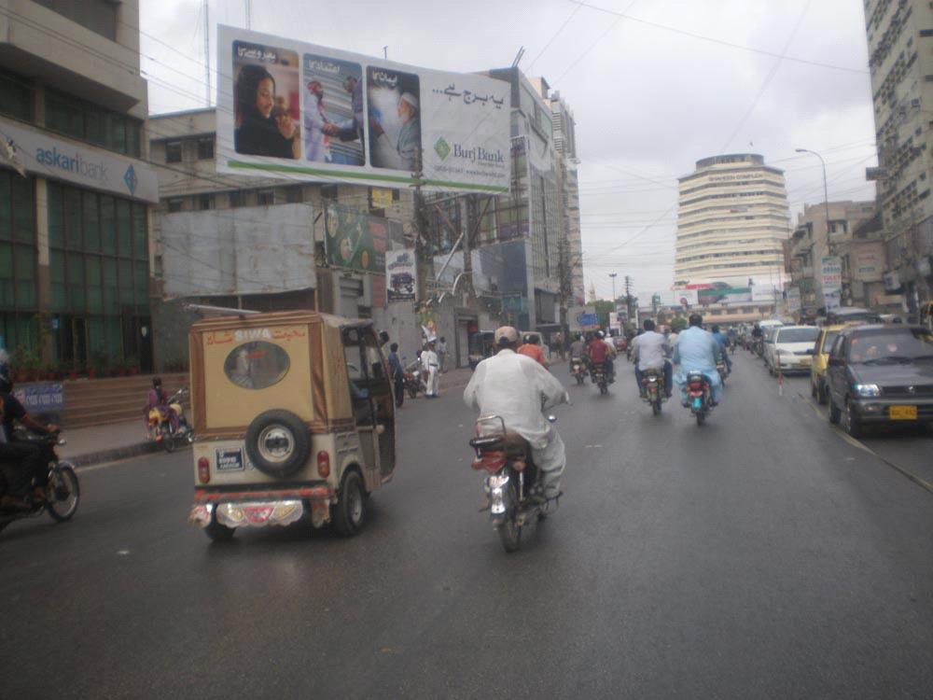

Location ID
175
Size
60 x 20
Available Date
15-May-13
Current Display
Burj Bank

Location Detail Huma Shaadi Lawn, I.I. Chundrighar Road Tower towards Shaheen Complex
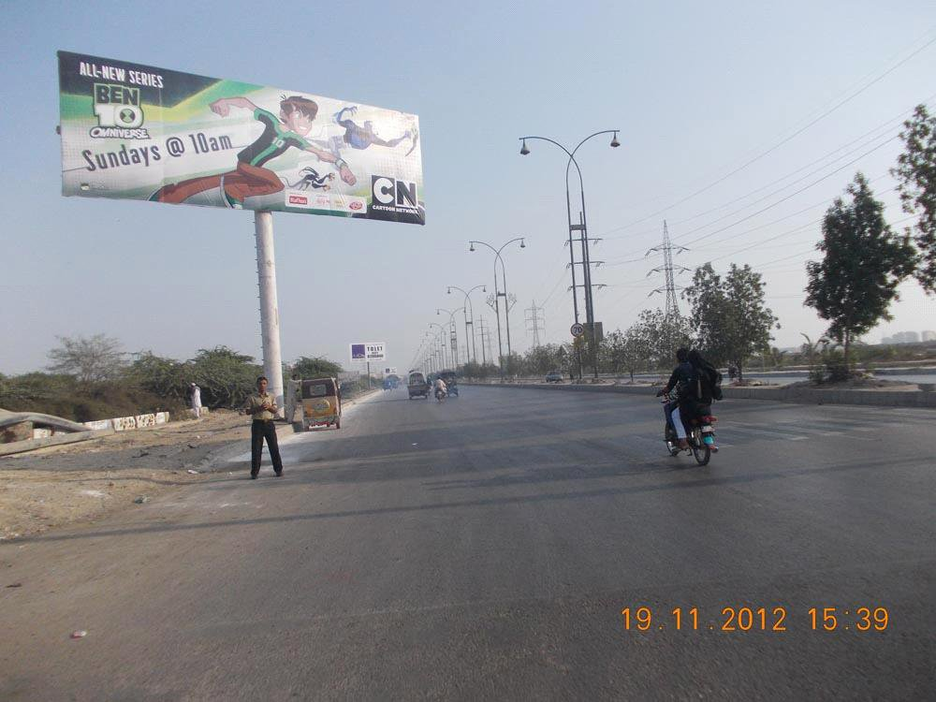

Location ID
3443
Size
45 x 15
Available Date

Current Display

Location Detail New American Embassy towards Boat Basin

